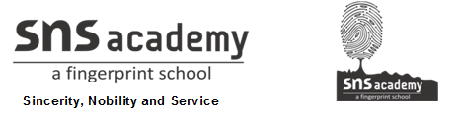SOCIAL STUDIES
GRADE: V DATE: 2.12.20
WORKSHEET - 16
16. INDIA WINS FREEDOM
I. Write a few lines on each.
1. Radicals

_______________________________________________________________
2. Indian National Congress

________________________________________________________________
3. Swadeshi

________________________________________________________________
4. Independent India

________________________________________________________________
II. Answer the Following
1. Who gave the Slogan ‘Jai Hind”?

________________________________________________________________
2. When did the Congress demand ‘Purna Swaraj’ from the British Government?

________________________________________________________________
3. Why did the Indian National Congress launch the Swadeshi and Boycott Movement?

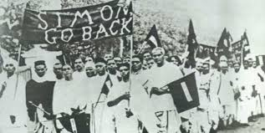
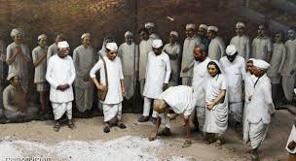
III. Identify the Movement ( Dandi March, Simon Commission, Non-Co-operation movement)

___________________________ ___________________________




